Cheltenham Branch of the British Horological Institute

Bring & Buy Sale
Saturday 6th July 2019
10.00 a.m. – 2.00 p.m.
at
Cotswold Area Civil Service Sports Association
Tewkesbury Road, Uckington, Cheltenham GL51 9SL

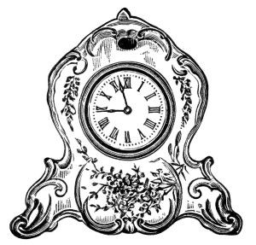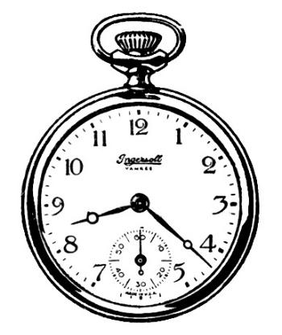
Clocks Watches
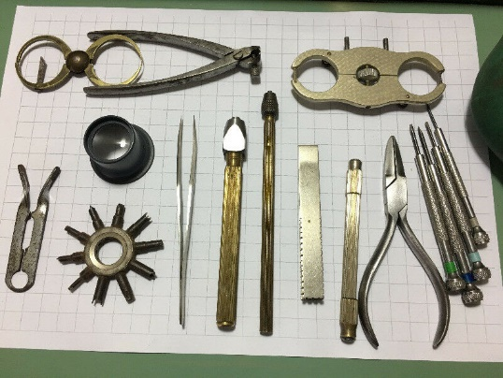
Tools
For information and to book tablespace please contact D. Hargreaves dkah26@gmail.com
All transactions to be in cash. Sellers to give 10% of sales to Branch Funds
See the website www.bhicheltenham.uk for a preliminary list of sale items.

