The Cheltenham Branch Committee of the
British Horological Institute

Invite you to the meeting of 21st February 2018
Where our Guest Speaker is:

Mr Ronald E. Rose FBHI
on
The Cole Family of Clockmakers

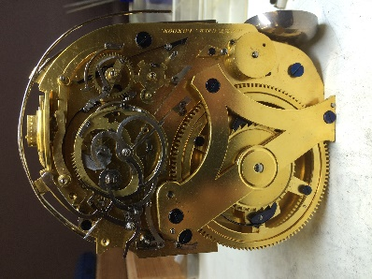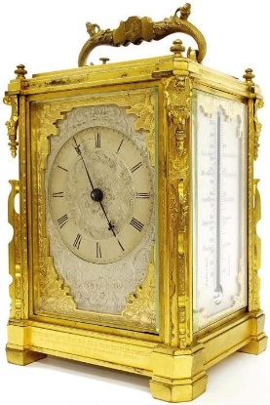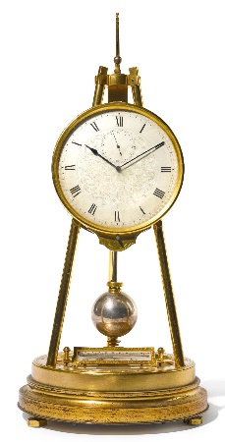
James Ferguson Thomas Cole Thomas Cole
& Thomas Cole Carriage Clock Tripod Clock
Back plate

Photographs courtesy of Ronald Rose FBHI

